Area Conditions

Definition
# Source: AI Source: Provided by: [Data Path: Persons Table -> ID Column: 1, Name_En Column: Motasem Essam] -> From: [ChatGPT] on [7/25/2026]
Area Conditions are geometric conditions that specify, compare, or constrain the area of a geometric figure or region.
They may require an area to have a fixed value, equal another area, be larger or smaller than another area, follow a particular ratio, or satisfy a formula or geometric relationship.
Simple Definition
An Area Condition is a geometric requirement involving the size of a two-dimensional region.
For example:
$$\left[ABC\right]=20$$
means that the area of triangle $ABC$must be $20$square units.

Main Classification
# Source: AI Source: Provided by: [Data Path: Persons Table -> ID Column: 1, Name_En Column: Motasem Essam] -> From: [ChatGPT] on [7/25/2026]
A practical classification of Area Conditions is:
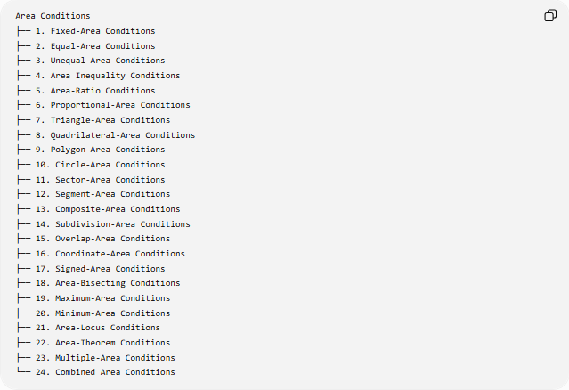
Area Conditions
├── 1. Fixed-Area Conditions
├── 2. Equal-Area Conditions
├── 3. Unequal-Area Conditions
├── 4. Area Inequality Conditions
├── 5. Area-Ratio Conditions
├── 6. Proportional-Area Conditions
├── 7. Triangle-Area Conditions
├── 8. Quadrilateral-Area Conditions
├── 9. Polygon-Area Conditions
├── 10. Circle-Area Conditions
├── 11. Sector-Area Conditions
├── 12. Segment-Area Conditions
├── 13. Composite-Area Conditions
├── 14. Subdivision-Area Conditions
├── 15. Overlap-Area Conditions
├── 16. Coordinate-Area Conditions
├── 17. Signed-Area Conditions
├── 18. Area-Bisecting Conditions
├── 19. Maximum-Area Conditions
├── 20. Minimum-Area Conditions
├── 21. Area-Locus Conditions
├── 22. Area-Theorem Conditions
├── 23. Multiple-Area Conditions
└── 24. Combined Area Conditions

3. Fixed-Area Conditions
# Source: AI Source: Provided by: [Data Path: Persons Table -> ID Column: 1, Name_En Column: Motasem Essam] -> From: [ChatGPT] on [7/25/2026]
Definition
A Fixed-Area Condition requires a geometric figure or region to have a specified area.
$$A=K$$
where $K$is a constant.
Example
A triangle must have area $30$:
$$\left[ABC\right]=30$$
If its base is $10$, then
$$30=\frac{1}{2}\left(10\right)h$$
so
$$h=6.$$
Key Idea
A fixed area determines a constraint on the dimensions of a figure, but it usually does not determine the figure uniquely.
For example, many rectangles can have area $24$:
$$1×24, 2×12, 3×8, 4×6.$$

4. Equal-Area Conditions
# Source: AI Source: Provided by: [Data Path: Persons Table -> ID Column: 1, Name_En Column: Motasem Essam] -> From: [ChatGPT] on [7/25/2026]
Definition
An Equal-Area Condition requires two or more regions to have exactly the same area.
$$A_{1}=A_{2}$$
Example
If two triangles have the same base and the same altitude:
$$b_{1}=b_{2}, h_{1}=h_{2},$$
then
$$A_{1}=A_{2}=\frac{1}{2}bh.$$
Another common example is dividing a figure into two equal-area regions:
$$A_{1}=A_{2}=\frac{A_{\text{total}}}{2}.$$
Important Point
Equal area does not mean congruent.
Two rectangles can both have area $20$:
$$4×5$$
and
$$2×10,$$
but they are not congruent.

5. Unequal-Area Conditions
# Source: AI Source: Provided by: [Data Path: Persons Table -> ID Column: 1, Name_En Column: Motasem Essam] -> From: [ChatGPT] on [7/25/2026]
Definition
An Unequal-Area Condition requires two areas to be different.
$$A_{1}≠A_{2}.$$
Example
If
$$\left[ABC\right]=20$$
and
$$\left[DEF\right]=25,$$
then
$$\left[ABC\right]≠\left[DEF\right].$$
Logical Form
$$A_{1}≠A_{2}$$
is equivalent to
$$A_{1}<A_{2} \text{or} A_{1}>A_{2}.$$

6. Area Inequality Conditions
# Source: AI Source: Provided by: [Data Path: Persons Table -> ID Column: 1, Name_En Column: Motasem Essam] -> From: [ChatGPT] on [7/25/2026]
Definition
An Area Inequality Condition compares areas using $<,>,≤,≥$.
Examples:
$$A_{1}>A_{2} \\ A_{1}<A_{2} \\ A_{1}≥A_{2} \\ A_{1}≤A_{2}.$$
Example
If a rectangle has area $A_{R}$and an inscribed triangle has area $A_{T}$, then
$$A_{T}≤A_{R}.$$
Strict vs Non-Strict
Strict:
$$A_{1}>A_{2}$$
means $A_{1}$must be strictly larger.
Non-strict:
$$A_{1}≥A_{2}$$
allows equality.

7. Area-Ratio Conditions
# Source: AI Source: Provided by: [Data Path: Persons Table -> ID Column: 1, Name_En Column: Motasem Essam] -> From: [ChatGPT] on [7/25/2026]
Definition
An Area-Ratio Condition specifies a ratio between two areas.
$$\frac{A_{1}}{A_{2}}=k.$$
Example
If
$$\frac{\left[ABC\right]}{\left[DEF\right]}=2,$$
then
$$\left[ABC\right]=2\left[DEF\right].$$
If
$$\left[DEF\right]=15,$$
then
$$\left[ABC\right]=30.$$
Ratio Form
$$A_{1}:A_{2}=2:1.$$

8. Proportional-Area Conditions
# Source: AI Source: Provided by: [Data Path: Persons Table -> ID Column: 1, Name_En Column: Motasem Essam] -> From: [ChatGPT] on [7/25/2026]
Definition
A Proportional-Area Condition requires areas to change in a specified proportional relationship.
For similar figures with linear scale factor $k$:
$$\frac{A_{2}}{A_{1}}=k^{2}.$$
Example
If the side lengths of a square are doubled:
$$k=2,$$
then its area becomes
$$k^{2}=4$$
times as large.
So:
$$A_{2}=4A_{1}.$$
Important Relationship
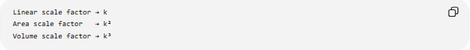
Linear scale factor → k
Area scale factor → k²
Volume scale factor → k³

9. Triangle-Area Conditions
# Source: AI Source: Provided by: [Data Path: Persons Table -> ID Column: 1, Name_En Column: Motasem Essam] -> From: [ChatGPT] on [7/25/2026]
Triangle-area conditions involve the area of triangles.
Basic Formula
$$K=\frac{1}{2}bh$$
where:
- $b$= base
- $h$= corresponding altitude.
Example
If
$$b=12, h=5,$$
then
$$K=\frac{1}{2}\left(12\right)\left(5\right)=30.$$
Other Triangle-Area Conditions
Using two sides and the included angle:
$$K=\frac{1}{2}ab\sin{C}.$$
Using Heron's formula:
$$K=\sqrt{s\left(s-a\right)\left(s-b\right)\left(s-c\right)}$$
where
$$s=\frac{a+b+c}{2}.$$

10. Quadrilateral-Area Conditions
# Source: AI Source: Provided by: [Data Path: Persons Table -> ID Column: 1, Name_En Column: Motasem Essam] -> From: [ChatGPT] on [7/25/2026]
Definition
These conditions concern the area of quadrilaterals such as rectangles, parallelograms, trapezoids, and rhombi.
Rectangle
$$A=lw.$$
Example:
$$l=8, w=5$$
gives
$$A=40.$$
Parallelogram
$$A=bh.$$
Trapezoid
$$A=\frac{1}{2}\left(a+b\right)h.$$
Rhombus / Kite
$$A=\frac{1}{2}d_{1}d_{2}.$$

11. Polygon-Area Conditions
# Source: AI Source: Provided by: [Data Path: Persons Table -> ID Column: 1, Name_En Column: Motasem Essam] -> From: [ChatGPT] on [7/25/2026]
Definition
These conditions specify or compare the areas of polygons.
For a regular polygon:
$$A=\frac{1}{2}Pa$$
where:
- $P$= perimeter
- $a$= apothem.
Example
A regular hexagon with side length $s$has
$$A=\frac{3\sqrt{3}}{2}s^{2}.$$
If $s=4$:
$$A=\frac{3\sqrt{3}}{2}\left(16\right)=24\sqrt{3}.$$

12. Circle-Area Conditions
# Source: AI Source: Provided by: [Data Path: Persons Table -> ID Column: 1, Name_En Column: Motasem Essam] -> From: [ChatGPT] on [7/25/2026]
Definition
These conditions involve the area enclosed by a circle.
For radius $r$:
$$A=πr^{2}.$$
Example
If
$$r=5,$$
then
$$A=25π.$$
Area-Ratio Relationship
If two circles have radii $r_{1},r_{2}$:
$$\frac{A_{1}}{A_{2}}=\frac{r_{1}^{2}}{r_{2}^{2}}.$$
Therefore, if
$$r_{2}=2r_{1},$$
then
$$A_{2}=4A_{1}.$$

13. Sector-Area Conditions
# Source: AI Source: Provided by: [Data Path: Persons Table -> ID Column: 1, Name_En Column: Motasem Essam] -> From: [ChatGPT] on [7/25/2026]
Definition
A Sector-Area Condition involves the area of a sector of a circle.
For central angle $θ$in degrees:
$$A=\frac{θ}{{360}^{∘}}πr^{2}.$$
For radians:
$$A=\frac{1}{2}r^{2}θ.$$
Example
For $r=6$and
$$θ={60}^{∘}, \\ A=\frac{60}{360}π\left(6^{2}\right)=6π.$$

14. Segment-Area Conditions
# Source: AI Source: Provided by: [Data Path: Persons Table -> ID Column: 1, Name_En Column: Motasem Essam] -> From: [ChatGPT] on [7/25/2026]
Definition
A Segment-Area Condition involves the area bounded by a chord and its corresponding circular arc.
For a minor segment:
$$A_{\text{segment}}=A_{\text{sector}}-A_{\text{triangle}}.$$
Example
If a sector has area $20$and its associated triangle has area $12$:
$$A_{\text{segment}}=20-12=8.$$

15. Composite-Area Conditions
# Source: AI Source: Provided by: [Data Path: Persons Table -> ID Column: 1, Name_En Column: Motasem Essam] -> From: [ChatGPT] on [7/25/2026]
Definition
A Composite-Area Condition involves a region formed from multiple simpler geometric figures.
The total area can be found by addition or subtraction:
$$A_{\text{total}}=A_{1}+A_{2}+⋯$$
or
$$A_{\text{total}}=A_{\text{large}}-A_{\text{removed}}.$$
Example
A rectangle of area $100$contains a circular hole of area $25π$.
The remaining area is
$$A=100-25π.$$

16. Subdivision-Area Conditions
# Source: AI Source: Provided by: [Data Path: Persons Table -> ID Column: 1, Name_En Column: Motasem Essam] -> From: [ChatGPT] on [7/25/2026]
Definition
A Subdivision-Area Condition requires a figure to be divided into regions with specified areas or area relationships.
Example
A triangle has area $60$and is divided into three regions of equal area.
Then:
$$A_{1}=A_{2}=A_{3}=20.$$
Another Example
If
$$A_{1}:A_{2}=2:3$$
and total area is $50$, let
$$A_{1}=2x, A_{2}=3x.$$
Then:
$$5x=50$$
so
$$x=10.$$
Therefore:
$$A_{1}=20, A_{2}=30.$$

17. Overlap-Area Conditions
# Source: AI Source: Provided by: [Data Path: Persons Table -> ID Column: 1, Name_En Column: Motasem Essam] -> From: [ChatGPT] on [7/25/2026]
Definition
An Overlap-Area Condition concerns the area shared by two or more geometric regions.
For two regions $A$and $B$:
$$A_{\text{union}}=A_{A}+A_{B}-A_{A∩B}.$$
Example
Two regions have areas $30$and $20$, with an overlap of $5$.
Then:
$$A_{\text{union}}=30+20-5=45.$$
The overlap is:
$$A_{A∩B}=5.$$

18. Coordinate-Area Conditions
# Source: AI Source: Provided by: [Data Path: Persons Table -> ID Column: 1, Name_En Column: Motasem Essam] -> From: [ChatGPT] on [7/25/2026]
Definition
A Coordinate-Area Condition specifies an area using the coordinates of points.
For a triangle with vertices
$$\left(x_{1} , y_{1}\right), \left(x_{2} , y_{2}\right), \left(x_{3} , y_{3}\right),$$
the area is
$$K=\frac{1}{2}∣x_{1}\left(y_{2}-y_{3}\right)+x_{2}\left(y_{3}-y_{1}\right)+x_{3}\left(y_{1}-y_{2}\right)∣.$$
Example
For
$$A=\left(0 , 0\right), B=\left(6 , 0\right), C=\left(0 , 4\right),$$
the area is
$$K=\frac{1}{2}\left(6\right)\left(4\right)=12.$$
Thus the condition
$$\left[ABC\right]=12$$
is satisfied.

19. Signed-Area Conditions
# Source: AI Source: Provided by: [Data Path: Persons Table -> ID Column: 1, Name_En Column: Motasem Essam] -> From: [ChatGPT] on [7/25/2026]
Definition
A Signed-Area Condition assigns a positive or negative sign to an area depending on orientation.
For a triangle:
$$K_{s}=\frac{1}{2}∣\begin{matrix}x_{1} & y_{1} & 1 \\ x_{2} & y_{2} & 1 \\ x_{3} & y_{3} & 1\end{matrix}∣.$$
The ordinary geometric area is:
$$K=∣K_{s}∣.$$
Example
If reversing the order of the vertices changes
$$K_{s}=12$$
to
$$K_{s}=-12,$$
the ordinary area remains
$$∣K_{s}∣=12.$$
Signed areas are especially useful in coordinate geometry, polygon orientation, and computational geometry.

20. Area-Bisecting Conditions
# Source: AI Source: Provided by: [Data Path: Persons Table -> ID Column: 1, Name_En Column: Motasem Essam] -> From: [ChatGPT] on [7/25/2026]
Definition
An Area-Bisecting Condition requires a line, segment, or curve to divide a region into two equal-area parts.
$$A_{1}=A_{2}=\frac{1}{2}A_{\text{total}}.$$
Example
A rectangle has area $80$. A line bisects its area.
Each resulting region must have:
$$A_{1}=A_{2}=40.$$
Important Distinction
An area bisector does not necessarily divide the perimeter or side lengths equally.

21. Maximum-Area Conditions
# Source: AI Source: Provided by: [Data Path: Persons Table -> ID Column: 1, Name_En Column: Motasem Essam] -> From: [ChatGPT] on [7/25/2026]
Definition
A Maximum-Area Condition requires a figure to have the greatest possible area under specified constraints.
Example: Rectangle with Fixed Perimeter
For a rectangle with perimeter $P$:
$$A≤\frac{P^{2}}{16}.$$
Equality occurs when the rectangle is a square.
If
$$P=40,$$
then
$$A≤\frac{{40}^{2}}{16}=100.$$
Thus the maximum area is:
$$\boxed{100}.$$

22. Minimum-Area Conditions
# Source: AI Source: Provided by: [Data Path: Persons Table -> ID Column: 1, Name_En Column: Motasem Essam] -> From: [ChatGPT] on [7/25/2026]
Definition
A Minimum-Area Condition requires a figure to have the smallest possible area under specified constraints.
Example
Among triangles with a fixed base $b$and fixed altitude $h$, the area is fixed:
$$A=\frac{1}{2}bh.$$
In optimization problems, additional constraints determine which configuration minimizes the area.
Important Point
A minimum-area condition always depends on the constraints. Without constraints, a positive area can often be made arbitrarily small.

23. Isoperimetric Area Conditions
# Source: AI Source: Provided by: [Data Path: Persons Table -> ID Column: 1, Name_En Column: Motasem Essam] -> From: [ChatGPT] on [7/25/2026]
Definition
The Isoperimetric Inequality relates area and perimeter.
For a plane region:
$$\boxed{4πA≤P^{2}}.$$
Equivalently:
$$A≤\frac{P^{2}}{4π}.$$
Equality occurs for a circle.
Example
If
$$P=20,$$
then
$$A≤\frac{400}{4π}=\frac{100}{π}.$$
So among plane figures with perimeter $20$, the circle encloses the greatest area.

24. Area Conditions from Similarity
# Source: AI Source: Provided by: [Data Path: Persons Table -> ID Column: 1, Name_En Column: Motasem Essam] -> From: [ChatGPT] on [7/25/2026]
For similar figures with scale factor $k$:
$$\boxed{\frac{A_{2}}{A_{1}}=k^{2}}.$$
Example
Two similar triangles have corresponding sides in ratio
$$2:3.$$
Therefore their areas are in ratio:
$$2^{2}:3^{2}=4:9.$$
So:
$$\frac{A_{1}}{A_{2}}=\frac{4}{9}.$$

25. Area Conditions from Equal Bases and Altitudes
# Source: AI Source: Provided by: [Data Path: Persons Table -> ID Column: 1, Name_En Column: Motasem Essam] -> From: [ChatGPT] on [7/25/2026]
If two triangles have equal bases and equal corresponding altitudes:
$$b_{1}=b_{2}, h_{1}=h_{2},$$
then:
$$A_{1}=A_{2}.$$
More generally, if two triangles share the same altitude:
$$\frac{A_{1}}{A_{2}}=\frac{b_{1}}{b_{2}}.$$
Example
Two triangles have bases $6$and $9$and the same altitude.
Then:
$$\frac{A_{1}}{A_{2}}=\frac{6}{9}=\frac{2}{3}.$$

26. Area Conditions in Triangles with a Common Vertex
# Source: AI Source: Provided by: [Data Path: Persons Table -> ID Column: 1, Name_En Column: Motasem Essam] -> From: [ChatGPT] on [7/25/2026]
Suppose triangles $PAB$and $PAC$share the same altitude from $P$to line $ABC$.
Then:
$$\frac{\left[PAB\right]}{\left[PAC\right]}=\frac{AB}{AC}.$$
Example
If
$$AB=4, AC=10,$$
then:
$$\frac{\left[PAB\right]}{\left[PAC\right]}=\frac{4}{10}=\frac{2}{5}.$$
Thus:
$$\left[PAB\right]:\left[PAC\right]=2:5.$$

28. Area-Theorem Conditions
# Source: AI Source: Provided by: [Data Path: Persons Table -> ID Column: 1, Name_En Column: Motasem Essam] -> From: [ChatGPT] on [7/25/2026]
Many geometric theorems establish area relationships.
Triangle Area
$$K=\frac{1}{2}ab\sin{C}.$$
Heron's Formula
$$K=\sqrt{s\left(s-a\right)\left(s-b\right)\left(s-c\right)}.$$
Weitzenböck's Inequality
For a triangle:
$$a^{2}+b^{2}+c^{2}≥4\sqrt{3}K.$$
Therefore:
$$K≤\frac{a^{2}+b^{2}+c^{2}}{4\sqrt{3}}.$$
Equality occurs for an equilateral triangle.
Isoperimetric Inequality
$$4πA≤P^{2}.$$
These can therefore be viewed as important sources of area constraints.

30. Area-Locus Conditions
# Source: AI Source: Provided by: [Data Path: Persons Table -> ID Column: 1, Name_En Column: Motasem Essam] -> From: [ChatGPT] on [7/25/2026]
Definition
An Area-Locus Condition describes the set of points for which an area involving a moving point has a specified value.
Example
Let $A$and $B$be fixed points and $P$move.
Suppose:
$$\left[ABP\right]=K.$$
Since
$$\left[ABP\right]=\frac{1}{2}\left(AB\right)\left(h\right),$$
we require:
$$h=\frac{2K}{AB}.$$
Therefore, $P$must remain at a fixed perpendicular distance from line $AB$.
The locus consists of two lines parallel to $AB$, one on each side, at distance
$$\boxed{\frac{2K}{AB}}.$$
This is an important connection:
$$\text{Area Condition}→\text{Distance Condition}→\text{Locus}.$$

31. Multiple-Area Conditions
# Source: AI Source: Provided by: [Data Path: Persons Table -> ID Column: 1, Name_En Column: Motasem Essam] -> From: [ChatGPT] on [7/25/2026]
Definition
A Multiple-Area Condition imposes several area requirements simultaneously.
Example
Suppose:
$$\left[ABC\right]=20$$
and
$$\left[DEF\right]=30$$
and
$$\left[ABC\right]:\left[DEF\right]=2:3.$$
All conditions must hold simultaneously.
Another example:
$$A_{1}=A_{2}$$
and
$$A_{2}=2A_{3}.$$
Therefore:
$$A_{1}=A_{2}=2A_{3}.$$

32. Combined Area Conditions
# Source: AI Source: Provided by: [Data Path: Persons Table -> ID Column: 1, Name_En Column: Motasem Essam] -> From: [ChatGPT] on [7/25/2026]
Definition
A Combined Area Condition combines area requirements with other types of geometric conditions.
For example:
$$P∈AB$$
and
$$\left[ACP\right]=20.$$
Or:
$$AB∥CD$$
and
$$\left[ABC\right]=\left[BCD\right].$$
Or:
$$PA=5$$
and
$$\left[ABP\right]=15.$$
Example
Suppose:
$$AB=10$$
and
$$\left[ABP\right]=25.$$
Then:
$$25=\frac{1}{2}\left(10\right)h$$
so:
$$h=5.$$
Thus the area condition becomes a distance condition:
$$d\left(P , AB\right)=5.$$

27. Area Conditions and Parallel Lines
# Source: AI Source: Provided by: [Data Path: Persons Table -> ID Column: 1, Name_En Column: Motasem Essam] -> From: [ChatGPT] on [7/25/2026]
If two triangles have bases on the same line and the same altitude, their areas are proportional to their bases.
If the bases are equal, their areas are equal.
Example
If
$$AB∥CD$$
and two triangles have equal bases between the same parallel lines, then they have equal altitudes and therefore equal areas.
This is a common basis for equal-area constructions and geometric proofs.

Important Relationships
# Source: AI Source: Provided by: [Data Path: Persons Table -> ID Column: 1, Name_En Column: Motasem Essam] -> From: [ChatGPT] on [7/25/2026]
Area and Linear Scale
For similar figures:
$$\boxed{A_{2}=k^{2}A_{1}}.$$
Area and Perimeter
For a circle:
$$A=πr^{2}, P=2πr.$$
For fixed perimeter, the circle maximizes area.
Area and Height
For fixed triangle base:
$$A∝h.$$
Area and Base
For fixed triangle height:
$$A∝b.$$
Area and Radius
For circles:
$$A∝r^{2}.$$

Area Conditions vs Other Geometric Conditions
# Source: AI Source: Provided by: [Data Path: Persons Table -> ID Column: 1, Name_En Column: Motasem Essam] -> From: [ChatGPT] on [7/25/2026]
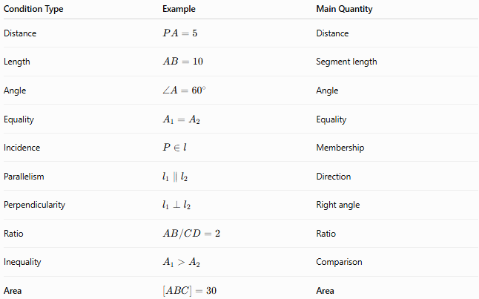
Condition Type | Example | Main Quantity
Distance | $$PA=5$$ | Distance
Length | $$AB=10$$ | Segment length
Angle | $$∠A={60}^{∘}$$ | Angle
Equality | $$A_{1}=A_{2}$$ | Equality
Incidence | $$P∈l$$ | Membership
Parallelism | $$l_{1}∥l_{2}$$ | Direction
Perpendicularity | $$l_{1}⊥l_{2}$$ | Right angle
Ratio | $$AB/CD=2$$ | Ratio
Inequality | $$A_{1}>A_{2}$$ | Comparison
Area | $$\left[ABC\right]=30$$ | Area
An Area Condition can also contain another type of condition.
For example:
$$\frac{\left[ABC\right]}{\left[DEF\right]}=2$$
is both an area condition and a ratio condition.

Area Conditions and Loci
# Source: AI Source: Provided by: [Data Path: Persons Table -> ID Column: 1, Name_En Column: Motasem Essam] -> From: [ChatGPT] on [7/25/2026]
Area conditions can generate loci.
A particularly important example is:
$$\left[ABP\right]=K.$$
Since:
$$\left[ABP\right]=\frac{1}{2}\left(AB\right)d\left(P , AB\right),$$
we obtain:
$$d\left(P , AB\right)=\frac{2K}{AB}.$$
Therefore:
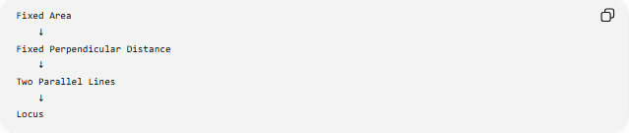
Fixed Area
↓
Fixed Perpendicular Distance
↓
Two Parallel Lines
↓
Locus
This demonstrates that area conditions can be transformed into distance conditions.

Area Conditions and Inequalities
# Source: AI Source: Provided by: [Data Path: Persons Table -> ID Column: 1, Name_En Column: Motasem Essam] -> From: [ChatGPT] on [7/25/2026]
Many optimization problems have the form:
$$A≤A_{max}$$
or
$$A≥A_{min}.$$
For example, a rectangle with perimeter $P$:
$$\boxed{A≤\frac{P^{2}}{16}}.$$
The equality case is:
$$A=\frac{P^{2}}{16}$$
when the rectangle is a square.
Thus:
$$\text{Inequality Condition}+\text{Equality Case}→\text{Optimization Condition}.$$

Area Conditions and Logical Operations
# Source: AI Source: Provided by: [Data Path: Persons Table -> ID Column: 1, Name_En Column: Motasem Essam] -> From: [ChatGPT] on [7/25/2026]
Multiple area conditions can be combined logically.
AND Condition
$$A_{1}=20 ∧ A_{2}=30.$$
Both conditions must be satisfied.
OR Condition
$$A_{1}=20 ∨ A_{2}=20.$$
At least one condition must be satisfied.
Equality and Ratio
$$A_{1}=A_{2}$$
is the special case
$$\frac{A_{1}}{A_{2}}=1.$$
Therefore, equal-area conditions are a special case of area-ratio conditions.

Classification Summary
# Source: AI Source: Provided by: [Data Path: Persons Table -> ID Column: 1, Name_En Column: Motasem Essam] -> From: [ChatGPT] on [7/25/2026]
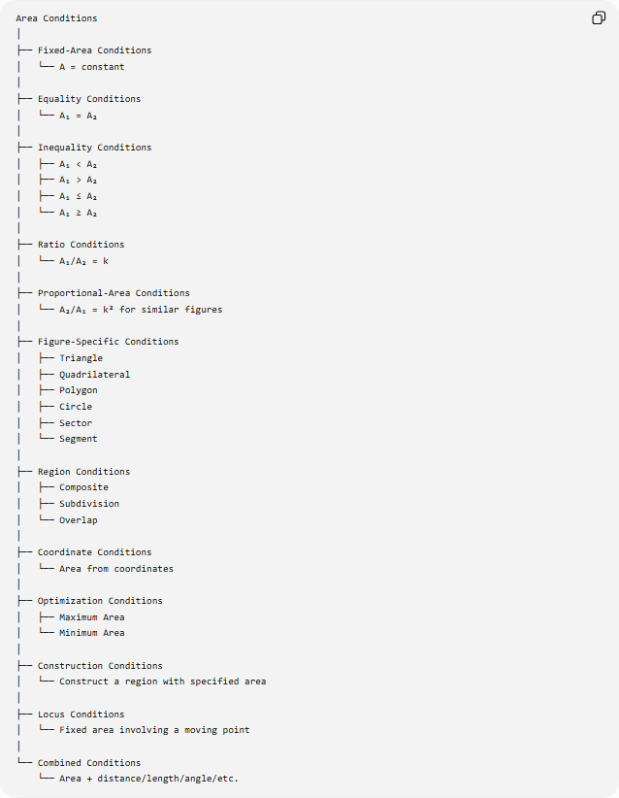
Area Conditions
│
├── Fixed-Area Conditions
│ └── A = constant
│
├── Equality Conditions
│ └── A₁ = A₂
│
├── Inequality Conditions
│ ├── A₁ < A₂
│ ├── A₁ > A₂
│ ├── A₁ ≤ A₂
│ └── A₁ ≥ A₂
│
├── Ratio Conditions
│ └── A₁/A₂ = k
│
├── Proportional-Area Conditions
│ └── A₂/A₁ = k² for similar figures
│
├── Figure-Specific Conditions
│ ├── Triangle
│ ├── Quadrilateral
│ ├── Polygon
│ ├── Circle
│ ├── Sector
│ └── Segment
│
├── Region Conditions
│ ├── Composite
│ ├── Subdivision
│ └── Overlap
│
├── Coordinate Conditions
│ └── Area from coordinates
│
├── Optimization Conditions
│ ├── Maximum Area
│ └── Minimum Area
│
├── Construction Conditions
│ └── Construct a region with specified area
│
├── Locus Conditions
│ └── Fixed area involving a moving point
│
└── Combined Conditions
└── Area + distance/length/angle/etc.

Key Formulas
# Source: AI Source: Provided by: [Data Path: Persons Table -> ID Column: 1, Name_En Column: Motasem Essam] -> From: [ChatGPT] on [7/25/2026]
Triangle
$$\boxed{K=\frac{1}{2}bh} \\ \boxed{K=\frac{1}{2}ab\sin{C}} \\ \boxed{K=\sqrt{s\left(s-a\right)\left(s-b\right)\left(s-c\right)}}$$
Rectangle
$$\boxed{A=lw}$$
Parallelogram
$$\boxed{A=bh}$$
Trapezoid
$$\boxed{A=\frac{1}{2}\left(a+b\right)h}$$
Rhombus / Kite
$$\boxed{A=\frac{1}{2}d_{1}d_{2}}$$
Circle
$$\boxed{A=πr^{2}}$$
Sector
$$\boxed{A=\frac{θ}{{360}^{∘}}πr^{2}}$$
or
$$\boxed{A=\frac{1}{2}r^{2}θ}$$
for $θ$in radians.
Similar Figures
$$\boxed{\frac{A_{2}}{A_{1}}=k^{2}}$$
Isoperimetric Inequality
$$\boxed{4πA≤P^{2}}$$
Weitzenböck's Inequality
$$\boxed{a^{2}+b^{2}+c^{2}≥4\sqrt{3}K}$$
Coordinate Triangle Area
$$\boxed{K=\frac{1}{2}∣x_{1}\left(y_{2}-y_{3}\right)+x_{2}\left(y_{3}-y_{1}\right)+x_{3}\left(y_{1}-y_{2}\right)∣}$$

Key Points
# Source: AI Source: Provided by: [Data Path: Persons Table -> ID Column: 1, Name_En Column: Motasem Essam] -> From: [ChatGPT] on [7/25/2026]
- Area Conditions specify requirements involving the size of two-dimensional regions.
- A fixed-area condition has the form:
$$A=K.$$
- Equal-area conditions have the form:
$$A_{1}=A_{2}.$$
- Area inequalities use:
$$<, >, ≤, ≥.$$
- Area-ratio conditions use:
$$\frac{A_{1}}{A_{2}}=k.$$
- Similar figures have an area ratio equal to the square of their linear scale factor:
$$k^{2}.$$
- Equal area does not imply congruence.
- A line that bisects area does not necessarily bisect perimeter or side lengths.
- Fixed-area conditions can sometimes be converted into distance conditions.
- Area conditions are fundamental in triangle geometry, polygons, circles, coordinate geometry, loci, constructions, inequalities, and optimization.

Conclusion
# Source: AI Source: Provided by: [Data Path: Persons Table -> ID Column: 1, Name_En Column: Motasem Essam] -> From: [ChatGPT] on [7/25/2026]
Area Conditions describe geometric requirements involving the size, comparison, ratio, division, or optimization of two-dimensional regions. They range from simple fixed-area requirements such as
$$\left[ABC\right]=30$$
to sophisticated conditions involving similarity, coordinate geometry, loci, and classical inequalities.
The central idea is:
$$\boxed{\text{Area Condition}→\text{Geometric Constraint}}$$
and that constraint can often be connected to other geometric conditions:
$$\boxed{\text{Area}→\text{Length/Distance}→\text{Ratio}→\text{Locus}→\text{Construction or Proof}}$$
Thus, Area Conditions form an important bridge between measurement, geometric relationships, inequalities, constructions, loci, and optimization.

